 | Rajalakshmi Engineering College  (An Autonomous Institution) Rajalakshmi Nagar, Thandalam-602105

ONLINE BUS PASS APPLICATION SYSTEM

WEEK 1
GITHUB LINK: https://github.com/jeevi2907/week-program-1.git

PROGRAM1
Design a simple static HTML web page using:
o Ordered lists
o Unordered lists
o Tables
Display and maintain student record information in a structured format.

<!DOCTYPE html>
<html>
<head>
<title>Online Bus Pass Application System</title>

<style>
body {
font-family: Arial, sans-serif;
background-color: #f0f8ff;
}

h1 {
text-align: center;
color: white;
background-color: #0077b6;
padding: 10px;
}

h2 {
color: #023e8a;
}

ul {
background-color: #caf0f8;
padding: 15px;
width: 300px;
border-radius: 8px;
}

ol {
background-color: #ade8f4;
padding: 15px;
width: 300px;
border-radius: 8px;
}

table {
border-collapse: collapse;
width: 80%;
margin-top: 20px;
background-color: white;
}

th {
background-color: #0077b6;
color: white;
padding: 10px;
}

td {
padding: 8px;
text-align: center;
}

table, th, td {
border: 1px solid black;
}

tr:nth-child(even) {
background-color: #e0f7fa;
}
</style>
</head>

<body>

<h1>Online Bus Pass Application System</h1>

<h2>Student General Details</h2>
<ul>
<li>Name: Rahul Kumar</li>
<li>Department: Computer Science</li>
<li>Year: 2nd Year</li>
<li>Section: A</li>
</ul>

<h2>Bus Pass Registration Steps</h2>
<ol>
<li>Fill out the online application form</li>
<li>Upload required documents</li>
<li>Submit college ID proof</li>
<li>Make payment</li>
<li>Download bus pass</li>
</ol>

<h2>Student Bus Pass Records</h2>
<table cellpadding="10" cellspacing="0">
<tr>
<th>Student ID</th>
<th>Name</th>
<th>Department</th>
<th>Route</th>
<th>Pass Type</th>
</tr>

<tr>
<td>101</td>
<td>Rahul Kumar</td>
<td>CSE</td>
<td>Route 5</td>
<td>Monthly</td>
</tr>

<tr>
<td>102</td>
<td>Priya Sharma</td>
<td>ECE</td>
<td>Route 3</td>
<td>Quarterly</td>
</tr>

<tr>
<td>103</td>
<td>Amit Verma</td>
<td>Mechanical</td>
<td>Route 7</td>
<td>Monthly</td>
</tr>

</table>

</body>
</html>

Output:
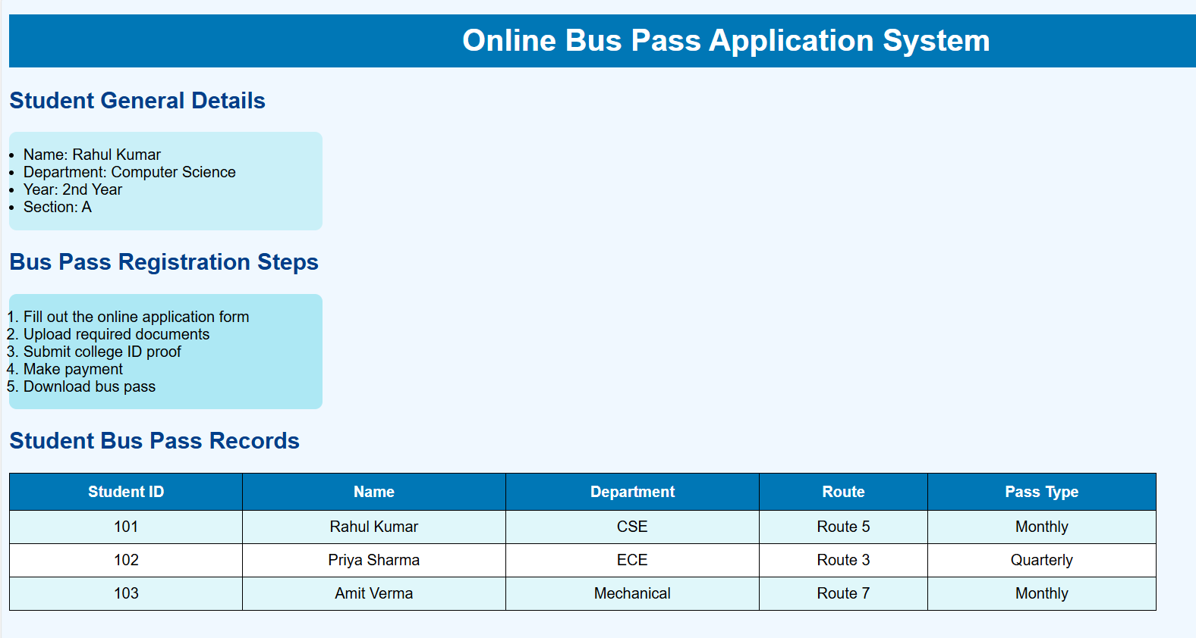

PROGRAM 2
Design static web pages for an online book store website:
o Home Page: Static home page with three frames
o Login Page
o Catalogue Page: Display all available books in a table
o Registration Page

<!DOCTYPE html>
<html>
<head>
<title>Catalogue Page</title>
</head>
<body>

<h2>Book Catalogue</h2>

<table border="1" cellpadding="10">
<tr>
<th>Book ID</th>
<th>Book Name</th>
<th>Author</th>
<th>Price</th>
</tr>

<tr>
<td>101</td>
<td>Introduction to HTML</td>
<td>John Smith</td>
<td>₹350</td>
</tr>

<tr>
<td>102</td>
<td>CSS Fundamentals</td>
<td>Mary Johnson</td>
<td>₹400</td>
</tr>

<tr>
<td>103</td>
<td>JavaScript Basics</td>
<td>David Miller</td>
<td>₹450</td>
</tr>

</table>

</body>
</html>

OUTPUT:

LOGIN PAGE:
<!DOCTYPE html>
<html>
<head>
<title>Login Page</title>
</head>
<body>

<h2>Login Page</h2>

<form>
Username:<br>
<input type="text" name="username"><br><br>

Password:<br>
<input type="password" name="password"><br><br>

<input type="submit" value="Login">
</form>

</body>
</html>

OUTPUT:
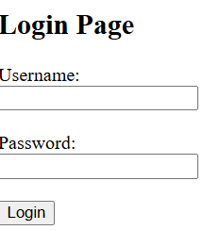

CATALOGUE PAGE:

<!DOCTYPE html>
<html>
<head>
<title>Catalogue Page</title>
</head>
<body>

<h2>Book Catalogue</h2>

<table border="1" cellpadding="10">
<tr>
<th>Book ID</th>
<th>Book Name</th>
<th>Author</th>
<th>Price</th>
</tr>

<tr>
<td>101</td>
<td>Introduction to HTML</td>
<td>John Smith</td>
<td>₹350</td>
</tr>

<tr>
<td>102</td>
<td>CSS Fundamentals</td>
<td>Mary Johnson</td>
<td>₹400</td>
</tr>

<tr>
<td>103</td>
<td>JavaScript Basics</td>
<td>David Miller</td>
<td>₹450</td>
</tr>

</table>

</body>
</html>
OUTPUT:
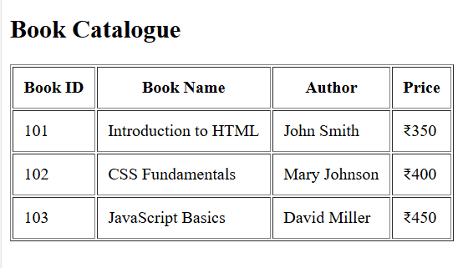
REGISTRATION PAGE:

<!DOCTYPE html>
<html>
<head>
<title>Registration Page</title>
</head>
<body>

<h2>Registration Form</h2>

<form>
Name:<br>
<input type="text" name="name"><br><br>

Email:<br>
<input type="email" name="email"><br><br>

Password:<br>
<input type="password" name="password"><br><br>

Gender:<br>
<input type="radio" name="gender" value="male"> Male
<input type="radio" name="gender" value="female"> Female<br><br>

Address:<br>
<textarea name="address" rows="4" cols="30"></textarea><br><br>

<input type="submit" value="Submit">
<input type="reset" value="Reset">

</form>

</body>
</html>
OUTPUT:

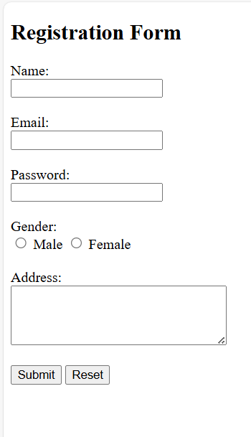

PROGRAM 3
Programme 3 - Design an HTML web page using anchor () tags and an iframe to display linked content within the same page.
The iframe should load a web page containing an image using the Error! Filename not specified.tag.

MAIN PAGE:
<!DOCTYPE html>
<html>
<head>
<title>Online Bus Pass Application System</title>
</head>
<body>

<h1>Online Bus Pass Application System</h1>

<p>
<a href="imagepage.html" target="displayFrame">
View Bus Pass Sample
</a>
</p>

<iframe name="displayFrame" width="600" height="400"
style="border:2px solid black;">
</iframe>

</body>
</html>
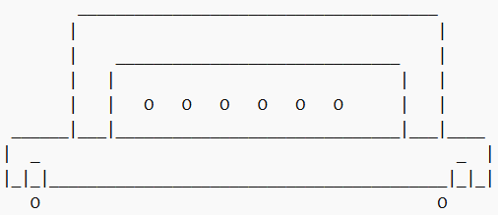

IMAGE PAGE:

<!DOCTYPE html>
<html>
<head>
<title>Bus Pass Image</title>
</head>
<body>

<h2>Sample Bus Pass</h2>

<img src="buspass.jpg"
width="400"
height="250"
alt="Sample Bus Pass Image">

</body>
</html>
OUTPUT:

SAMPLE BUS IMAGE


PROGRAM 4
Programme 4 - Create a web page using HTML that contains a form to collect student information including:
o Name
o Email
o Branch
o Gender
o Address

<!DOCTYPE html>
<html>
<head>
<title>Online Bus Pass Application - Student Form</title>
</head>
<body>

<h1>Online Bus Pass Application System</h1>
<h2>Student Information Form</h2>

<form action="submit.html" method="POST" id="buspassForm">

<!-- Name -->
<label>Full Name:</label><br>
<input type="text"
name="student_name"
placeholder="Enter your name"
required>
<br><br>

<!-- Email -->
<label>Email:</label><br>
<input type="email"
name="email"
placeholder="Enter your email"
required>
<br><br>

<!-- Branch -->
<label>Branch:</label><br>
<select name="branch" required>
<option value="">--Select Branch--</option>
<option value="CSE">CSE</option>
<option value="ECE">ECE</option>
<option value="EEE">EEE</option>
<option value="MECH">MECH</option>
</select>
<br><br>

<!-- Gender -->
<label>Gender:</label><br>
<input type="radio" name="gender" value="Male" required> Male
<input type="radio" name="gender" value="Female"> Female
<input type="radio" name="gender" value="Other"> Other
<br><br>

<!-- Address -->
<label>Address:</label><br>
<textarea name="address"
rows="4"
cols="40"
placeholder="Enter your address"
required>
</textarea>
<br><br>

<!-- Buttons -->
<input type="submit" value="Submit">
<input type="reset" value="Reset">

</form>

</body>
</html>

OUTPUT:

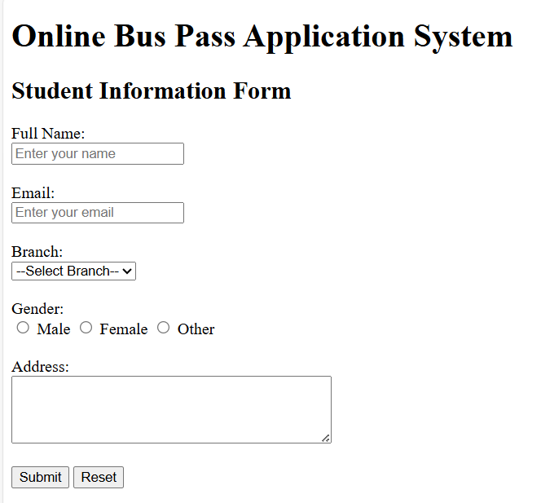

PROGRAM 5
Create a web page to embed a map along with:
o Hot spots
o Frames
o Link

<!DOCTYPE html>
<html>
<head>
<title>Online Bus Pass Application System</title>
</head>

<frameset cols="25%,75%">

<!-- Navigation Frame -->
<frame src="navigation.html" name="navFrame">

<!-- Display Frame (Map + Content) -->
<frame src="map.html" name="mainFrame">

</frameset>

</html>

OUTPUT: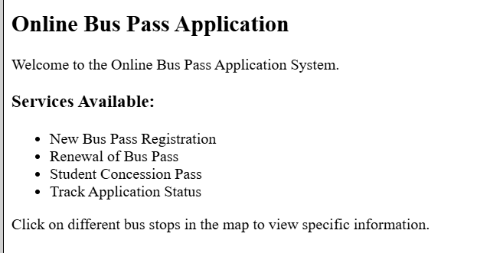
NAVIGATION LINKS:
<!DOCTYPE html>
<html>
<head>
<title>Navigation</title>
</head>
<body bgcolor="#f2f2f2">

<h3>Bus Pass Menu</h3>

<a href="map.html" target="mainFrame">View Bus Stops Map</a><br><br>
<a href="content.html" target="mainFrame">Apply for Bus Pass</a><br><br>
<a href="content.html" target="mainFrame">Check Application Status</a><br><br>
<a href="content.html" target="mainFrame">Contact Us</a><br><br>

</body>
</html>

OUTPUT:

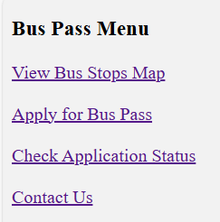

EMBED THE MAP:
<!DOCTYPE html>
<html>
<head>
<title>City Bus Stops Map</title>
</head>
<body>

<h2 align="center">City Bus Stops - Online Bus Pass System</h2>

<!-- Image Map -->
<img src="citymap.jpg" usemap="#busmap" width="600" height="400" border="1">

<map name="busmap">

<!-- Rectangle Hotspot -->
<area shape="rect" coords="50,60,150,150"
href="content.html"
target="mainFrame"
alt="Central Bus Stop">

<!-- Circle Hotspot -->
<area shape="circle" coords="300,200,40"
href="content.html"
target="mainFrame"
alt="Railway Station Stop">

<!-- Polygon Hotspot -->
<area shape="poly" coords="450,100,500,150,470,200,420,160"
href="content.html"
target="mainFrame"
alt="College Bus Stop">

</map>

</body>
</html>

OUTPUT:

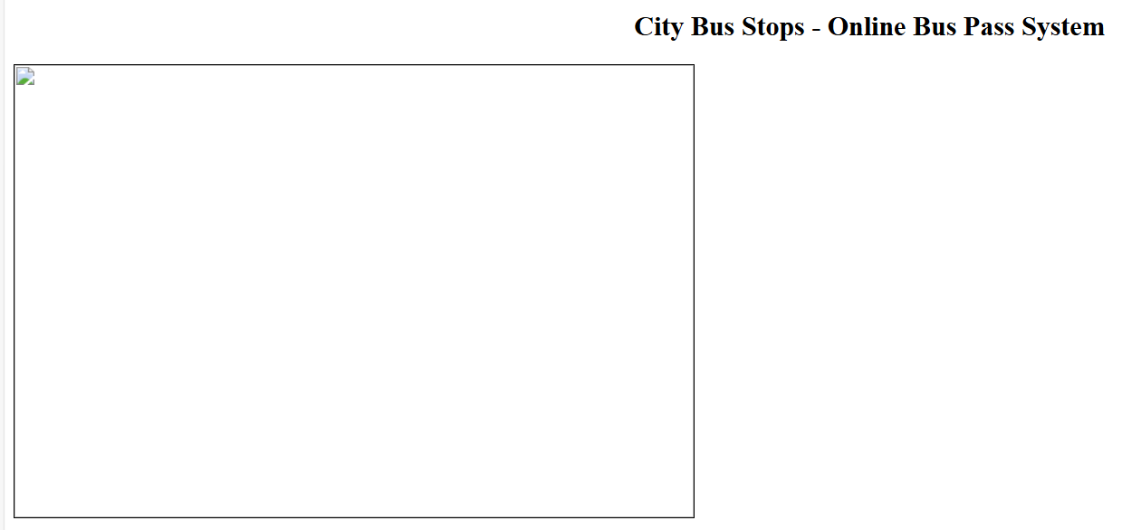


CONTENT PAGE:
<!DOCTYPE html>
<html>
<head>
<title>Bus Pass Information</title>
</head>
<body>

<h2>Online Bus Pass Application</h2>

<p>
Welcome to the Online Bus Pass Application System.
</p>

<h3>Services Available:</h3>
<ul>
<li>New Bus Pass Registration</li>
<li>Renewal of Bus Pass</li>
<li>Student Concession Pass</li>
<li>Track Application Status</li>
</ul>

<p>
Click on different bus stops in the map to view specific information.
</p>

</body>
</html>

OUTPUT

